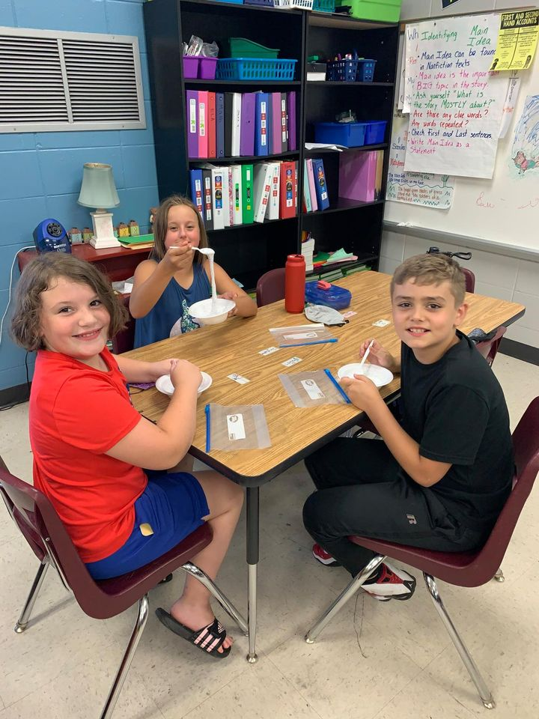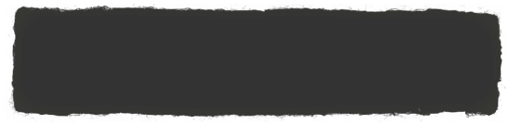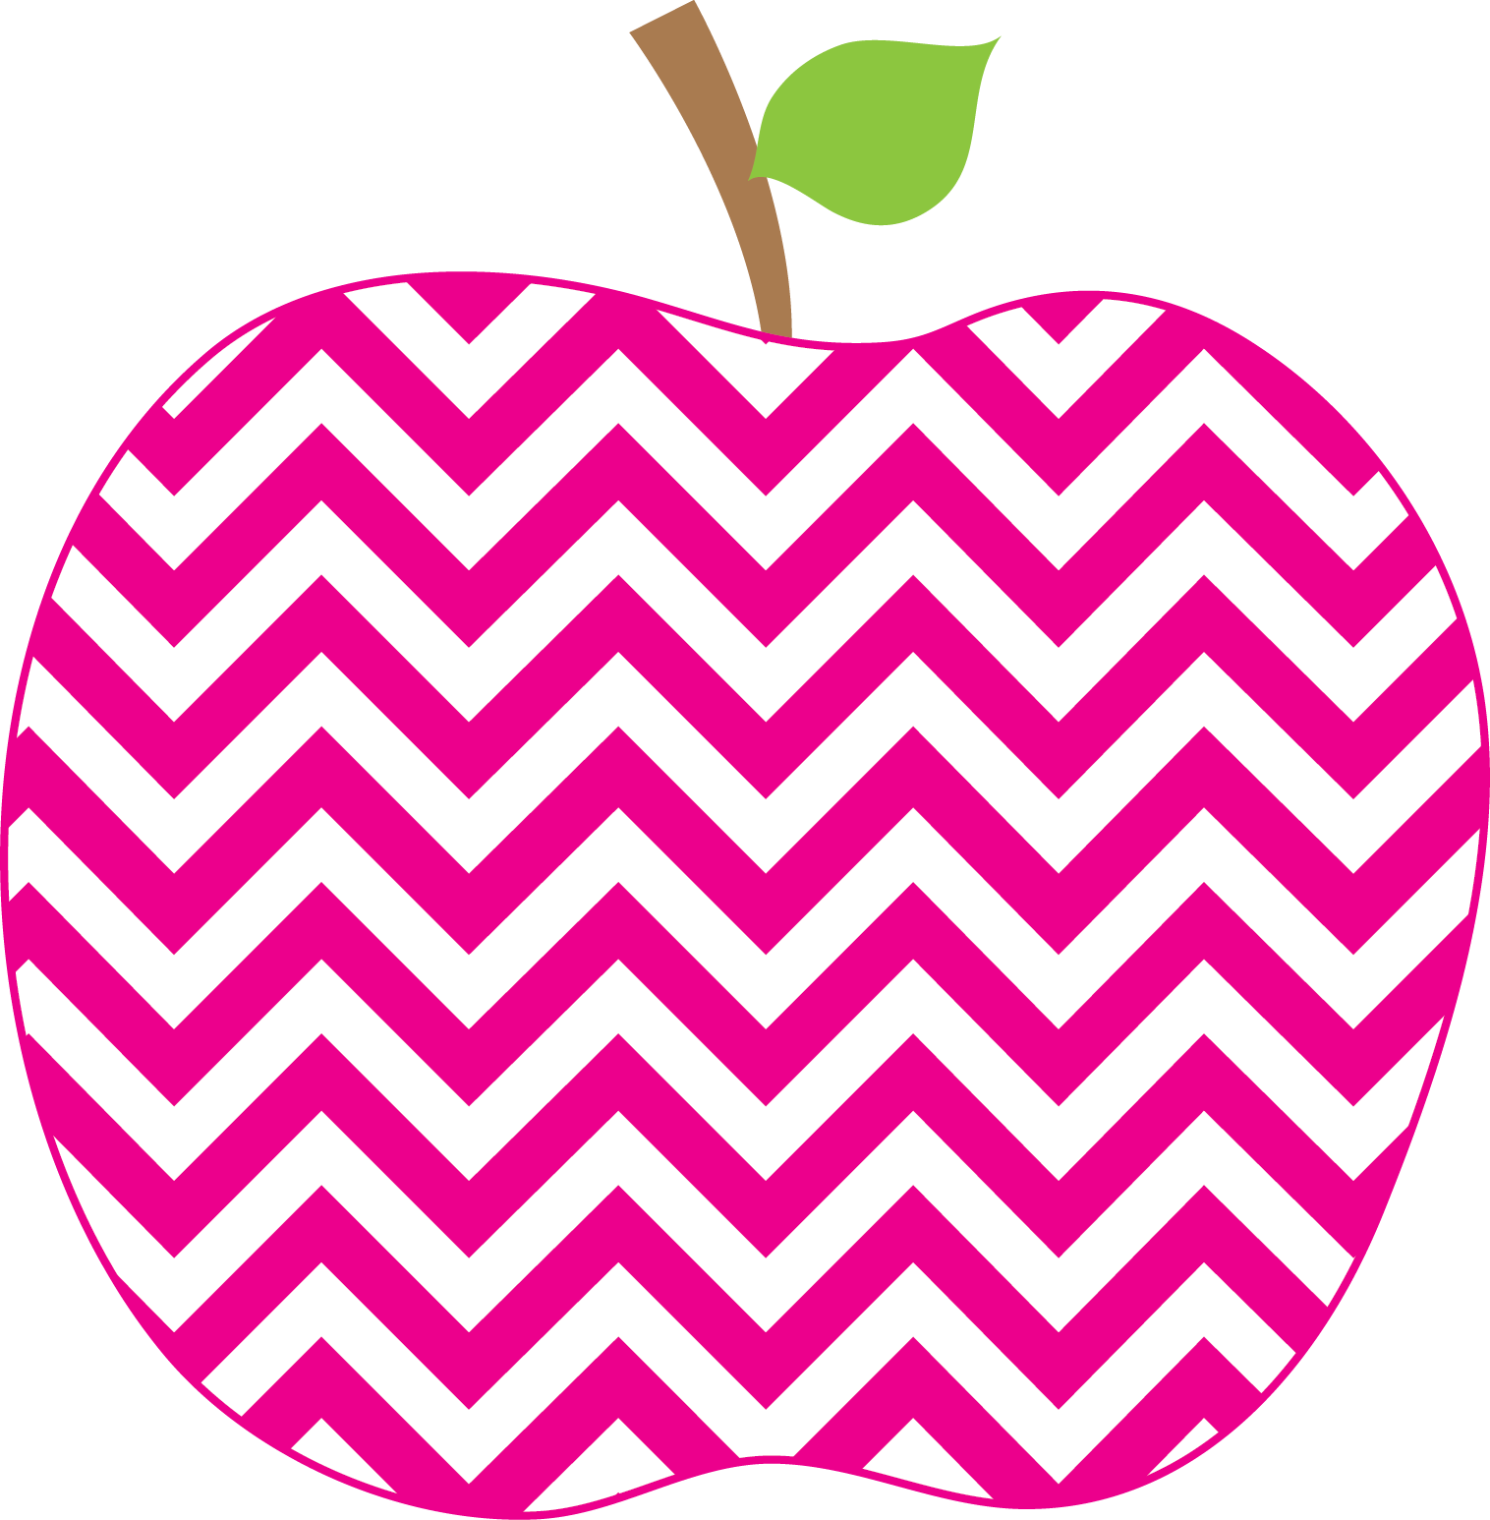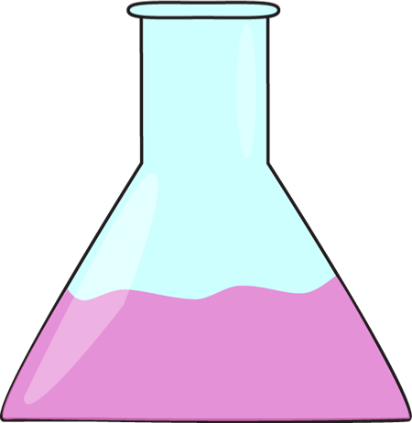

What is PBIS?

PBIS is a school wide behavior program. The goal is to improve the school environment with positive behaviors.

At Clear Creek Elementary

**Grow Together**

**Respect Others**

**Improve Everyday**

**Take Responsibility**

**Positive Behavior Interventions and Supports**

**(PBIS)-encouraging positive behaviors at your school.**

Enrichment dates

October 29, 2021

December 3, 2021

January 28, 2022

March 4, 2022

What’s new with PBIS?

Each teacher is now doing a station for enrichment, so there are many more choices for students. Teachers are getting really creative and the kids are loving it! We have had teachers sign up to do anything from fingernail painting, fake birthday parties, make your own pancakes to fun outdoor activities like soccer or wiffle ball.

What can I do at home?

* Go over school expectations with your child.
* Keep in touch with your child’s teacher
* Model appropriate behavior at home

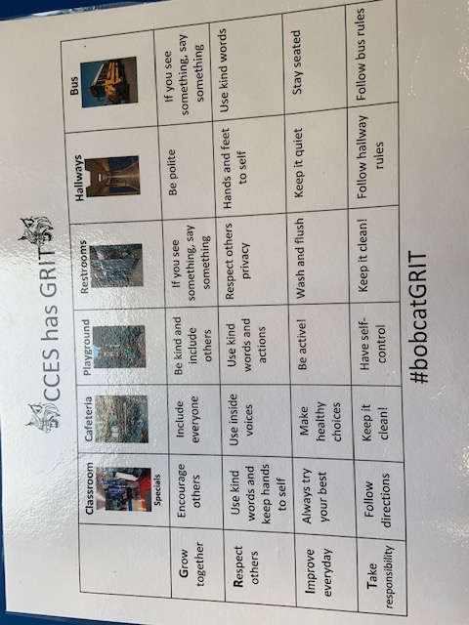

CCES Bobcat GRIT

What are these bucks coming home? When a student is caught showing expected behaviors, he/she will earn a buck! We also give coins for going above and beyond-which earns the student a free snack in the snack cart.

Bucks and Coins

Upcoming Events